# Create a new repository

# 

# Adding and Managing Files

# 

# Uploading a File

# 

# Creating a New File

# 

# 

# Creating a New Branch

# 

# 

# Merging a Branch (Using Pull Requests)

# 

# 

# Deleting a Branch

# 

# Adding Collaborators

# 

# 

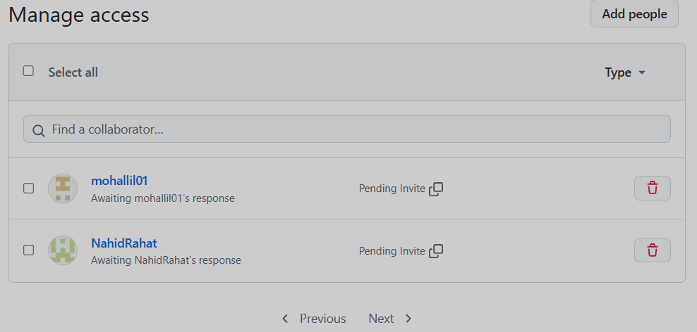

1. **Creating an Issue**

